Use the class cheat sheet and materials for reference: <https://bitbucket.org/lmcohort2/materials/src/master/cheatsheet.md>

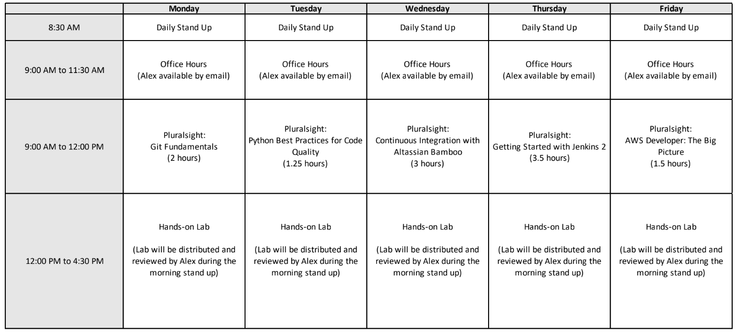

## Bamboo CI/CD

Bamboo should already be running on port 8085 on your workspace. The Pluralsight for today will be a good refresher for Build Plans and a primer for Deployment Projects. We will be building a full CI/CD pipeline for a Python Flask application. Python is not a compiled language. Therefore, a build artifact is just the source code itself. We want to make sure that code is tested before it is able to be deployed automatically to any of our environments.

useful links:

<https://confluence.atlassian.com/bamboo/bamboo-variables-289277087.html#Bamboovariables-Build-specificvariables>

### 1. Fork and run example app

<https://bitbucket.org/acmeade2/simple-flask-app>

You can run the example application with the following command. This will run the application in the background with all logs going to log.txt.

|  |
| --- |
| kill $(ps -ef |grep -v grep | grep -w "python.*hello.py" |awk '{print $2}')  nohup python3 hello.py >> /tmp/log.txt 2>&1 & |

You should then be able to view the app on port 5000

<http://localhost:5000>

The application will display debug information if the DEBUG environment variable is set. This would be a good idea when deploying to the dev environment.

### 2. Create Bamboo Build Plan

* Test flake8

* Run unittests

* Triggered by code push

- You can test this by changing hello.py (change "blue" to "green" for example) and pushing to your repo

### 3. Create Bamboo Deployment Project

* 3 environments

* Dev (Workspace)

* Test (VM 1, via SSH from Bamboo)

* Prod (VM 2, via SSH from Bamboo)

* Deploys should deploy the exact same code as the build chosen (release) to deploy. This means you will need to package an Artifact containing all of the code in the build (./*) in your build plan (under the job config) that is then downloaded in the Deployment Projects tasks (Artifact Download). Or you could use a [variable passed in from the build](https://confluence.atlassian.com/bamboo/bamboo-variables-289277087.html#Bamboovariables-Build-specificvariables) to ensure you checkout the proper commit.

* Dev environment should be redeployed after every successful build

** BONUS ** Deploys to production should add a tag of the release name in the git repo for the commit that was deployed, such as "release-11".

### 4. **Bonus** points if you deploy via Ansible